COMP 3850 – Assignment #3

**Do both questions.**

**Question 1**

Use Hebb learning to design a Hebb net with bipolar inputs and outputs to perform classification of the given input patterns shown below.

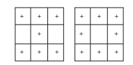

The plus symbol represents the value “1” and the empty squares “-1”. Consider that “I” belong to the class of interest (and so has target value 1) and “O” does not belong to this class (and so has target value -1). Draw the Hebb net.

Write a MATLAB program to verify your design (give a snip of your output).

**Question 2**

Use the back-propagation algorithm to find (one set of) new new weights for the net given below.

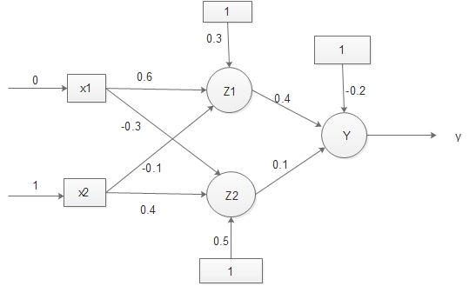

The net is presented with the input pattern [0, 1] and the target output is 1. use a learning rate of α = 0.25 and the binary sigmoidal activation function: f(x) = 1/(1 + exp(-x)).